**Structured Training Program: Networking**

**Week 1**

*Module 1: Communication Fundamentals & Module 2: Network Architecture and Network Protocol*

1. Consider a case, a folder has multiple files and how would you copy it to the machine destination path.

Answer:

Using cp command: cp command with ‘r’ flag can be used for recursively coping file from one directory to another

cmd: cp -r path/of/src-dir path/of/dst-dir

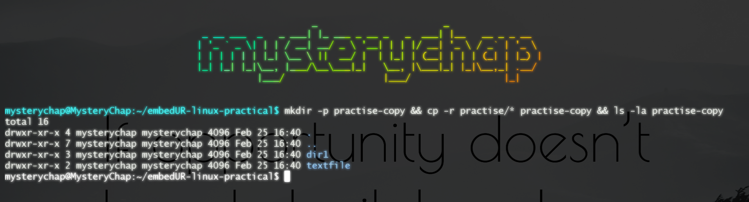

Using scp command: uses SSH to securely copy files across machines. cp is for local copy or transfer of file. scp is for copying file across machine. Similar to cp we can use -r flag in scp flag also to recursively copy files from the folder.

cmd: scp -r /path/of/src-dir path/of/dst-dir

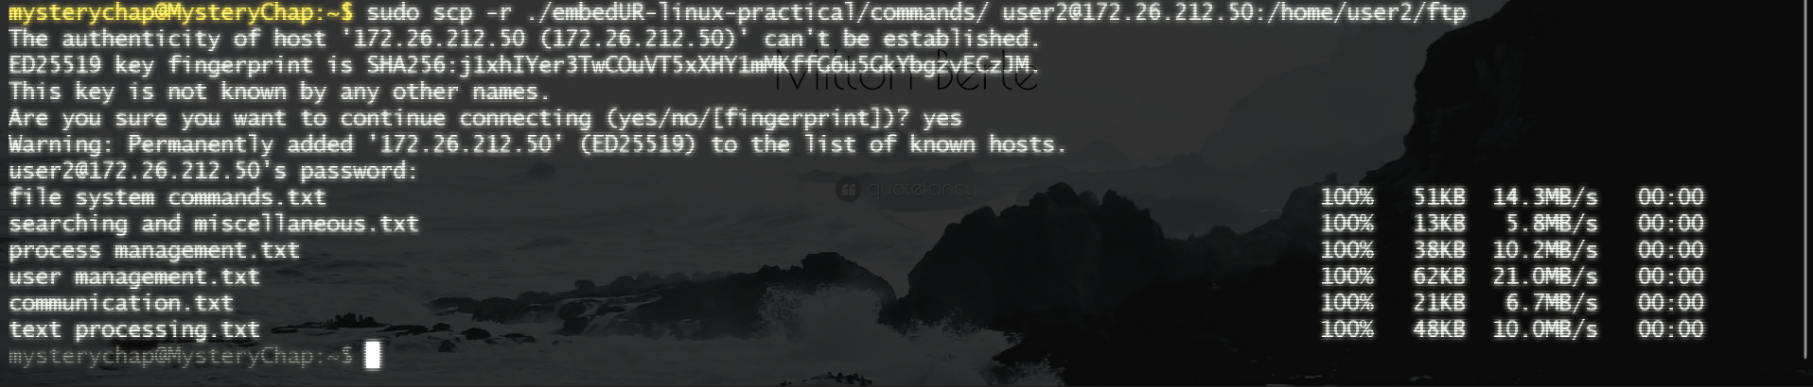

2. Host an FTP and SFTP server and try PUT and GET opertions.

Answer:

2.1) Configuring Trivial FTP server

a) Install the Very Secure File Transfer Protocol Daemon (vsftp) from apt package manager

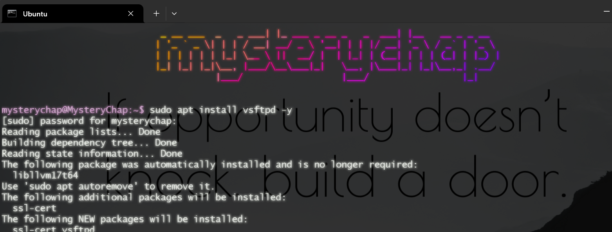

b) Start the daemon and enable it

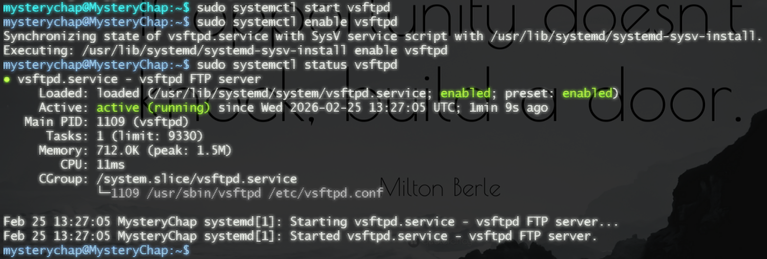

c) Create a backup of the original configuration file and configure the file

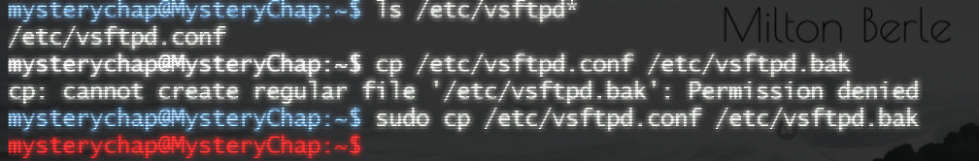

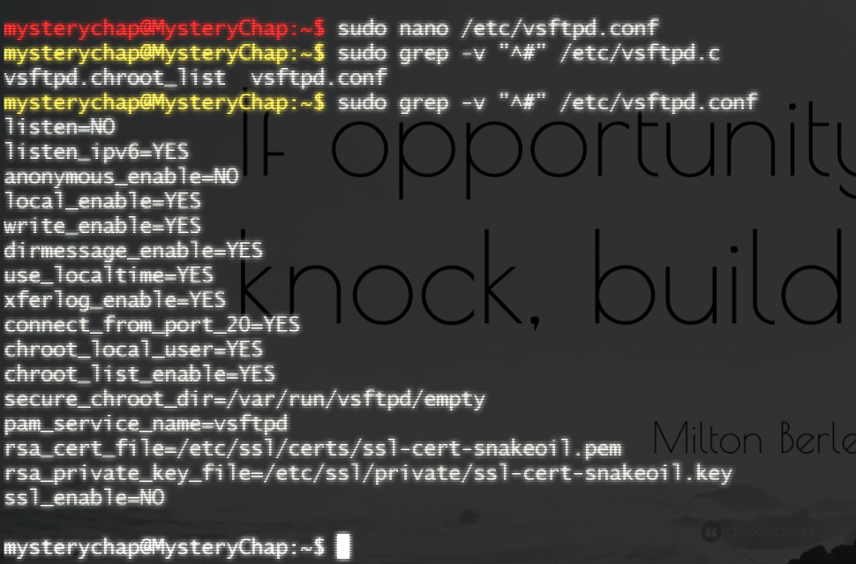

d) create a user particularly for FTP access

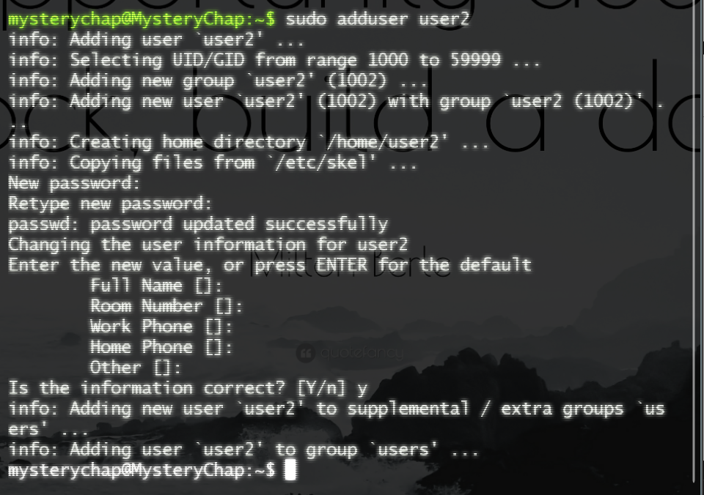

e) Create required directory for the FTP aceess. Since we have enables the chroot option in the configuration we have to change the home directory ownership to root. No other user must access that creating a security jail and have a folder accessable by ftp user.

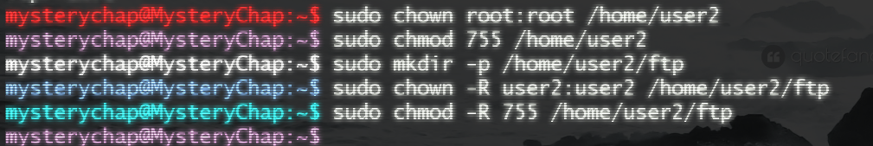

f) Create files for transfer.

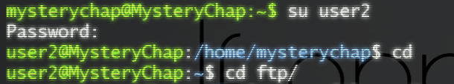 

g) Connect to the machine with its IP address and login with the ftp username and password

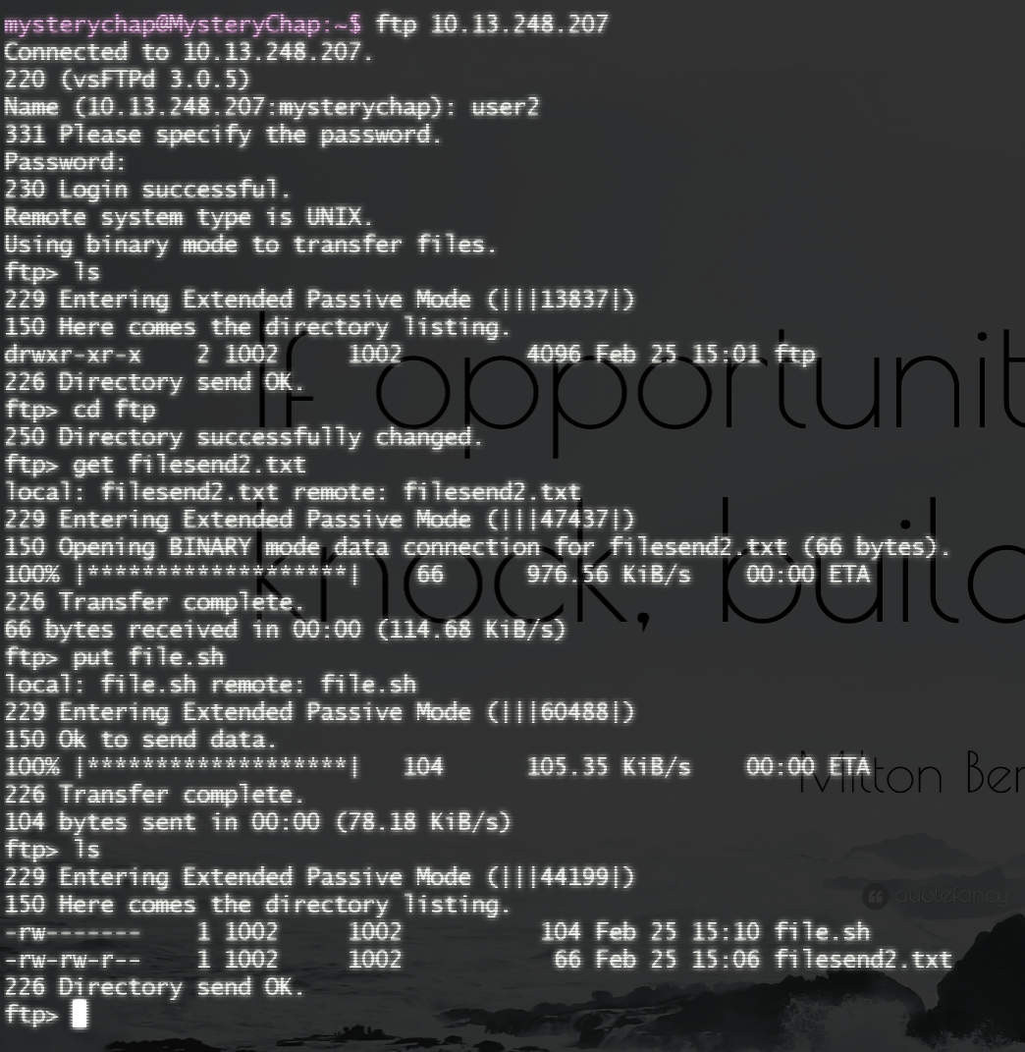

2.2) Configuring SFTP server that uses SSH in the Application layer along with FTP for encryption.

h) Install the openssh-server (this will install the additional required packages automatically)

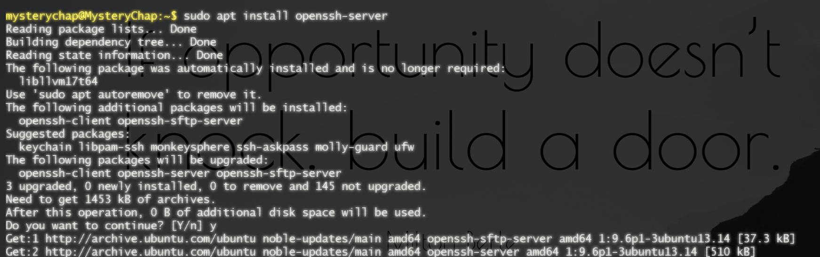

i) Now connect with the command ‘sftp’ and send and receive the required files with put an get files respectively.

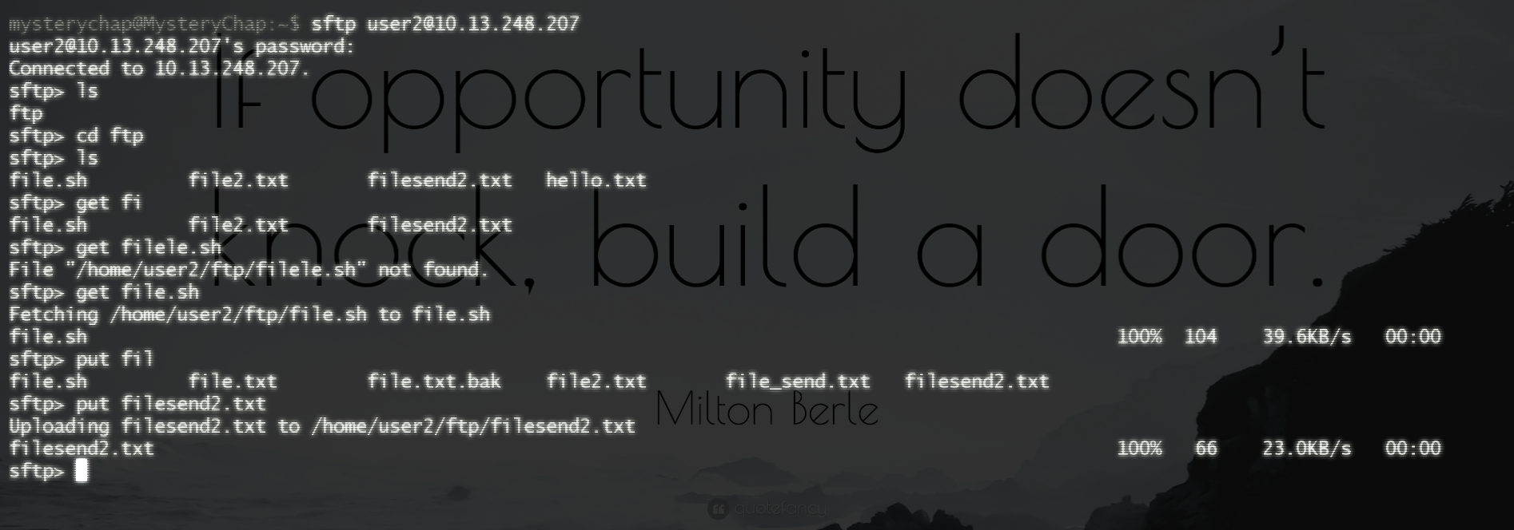

3) Explore with Wireshark/TCP-dump/cisco-packet-tracer tools and learn about packet filters

Answer:

Packet Filters: Packet filters are a fundamental network security technology, usually found in firewalls or routers, that inspect incoming and outgoing packets to allow or block them based on defined rules. They analyze packet headers—specifically source/destination IP addresses, ports, and protocols—to enforce security without examining the payload content.